Compost Coast to Coast
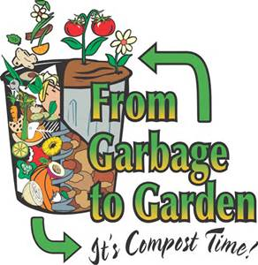

Brenden Narloch, Stephen Jinneman, Inga Shurnayte

Table of Contents

Position 1
History of the problem 1
Causes of the problem 2
Consequence of the problem 2
Proposed solution to the problem 2
Position of those who oppose 2-3
Visual graphics 3
Works cited 3-4

Position: The stance of Compost Coast to Coast is that people from all over need to compost much more than has taken place over the past. We believe that composting is overlooked as a way to recycle food waste, and is more beneficial to the environment than throwing away food waste in the trash and shipping it off to local landfills to be stored.
History of the problem: The main reason that trash has become such an issue is that all the trash created has to go somewhere and it all takes up too much space. Waste that can be put into compost makes up roughly 30% of all waste that is generated by humans. If this waste is taken out of the waste systems, then our landfills will fill up much slower than they currently are. This problem developed based on human nature, because people don’t want to make the extra effort to deal with composting themselves. Another reason this problem developed is because people don’t like the smell that is generated by composting, so they want to get rid of their waste as soon as possible by putting it into the trash system. The problem was discovered because landfills were filling up too fast, and it was seen that food waste was a big reason for the high rate of trash being created. To solve the issue, the “Compost Group” has built a mushroom compost production line in Vrsac. Also, “The Peninsula Compost Group”, has developed a facility to meet the growing demands for alternative ways to handle trash in the United States. Regarding relevant laws or treaties, there isn’t really much that is required of people. Composting is basically a person’s choice, and most people choose not to compost on their own.
Causes of the problem: The major cause of this problem is that people are unaware of the consequences of not composting and continue to add to the local landfills. Also, that the smell of composting contributes to people not wanting to change their traditional methods of tossing food waste into trash bins.
Consequences of the problem: Some of the present consequences that are taking place are that local landfills and waste sites are filling up much too quickly. Also, with more waste comes much more harm caused to the environment and this leaves a much bigger ecological footprint. With less yard waste and food scraps, more resources are being used with less being put back into the cycles. Some of the future consequences that will be taking place are landfills continuing to grow. Also, if the rate of waste production continues to rise then more and more resources will be depleted. This will lead to the suffering of future generations who must deal with this lack of resources.
Proposed solution to the problem: An idea of Compost Coast to Coast is for a Nation Wide Compost Campaign that will set up activities and speeches to crowds about composting. There will be exhibits set up at these events to teach the average American about composting and how easy it is to do. Also, this will help people get over the fear of not knowing how to compost and they can spread the word to others how composting can reduce the waste they have to throw away.
The position of those who oppose you: Many people who oppose composting as an alternative method for food scraps and yard waste do so for similar reasons. One of these reasons is because they don’t want to deal with the pest problems such as insects that are drawn to the smelly aroma of the compost bins. Another reason is because people are lazy, and think that composting is less convenient for them. They believe that traditional methods are easier and composting requires too much effort to make the switch and keep track of more often that a trash bin.
Rebuttal-To these people who believe these things, Compost Coast to Coast strongly disagrees with these accusations. The pest problems can easily be controlled with correct procedure on composting. Shutting all the windows and making sure to fan out the compost area can help greatly to rid of the smell. To the people who are concerned about the transition, Compost Coast to Coast believes that composting is easier than the public believes. Now here are some visuals to help make composting clearer:
Visual Images:

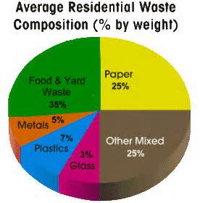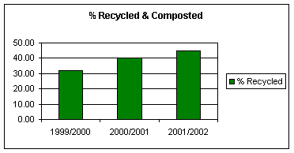

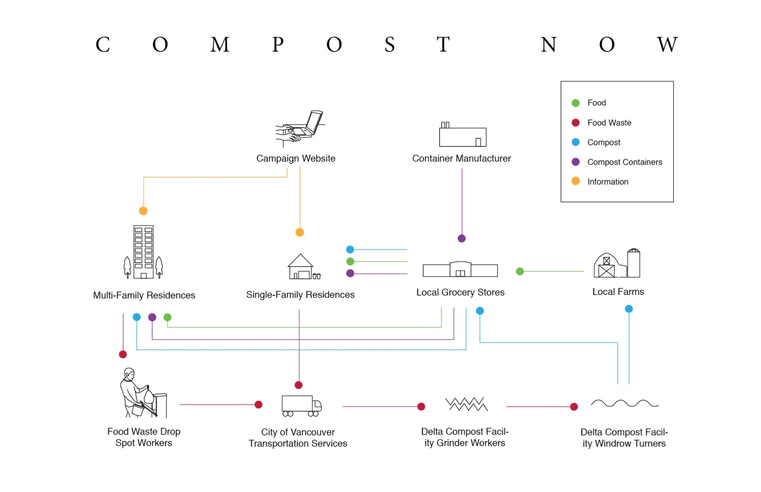
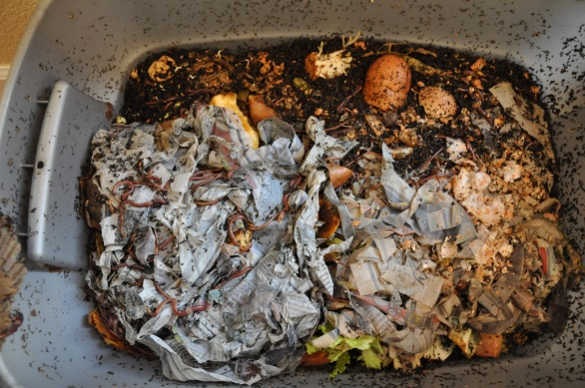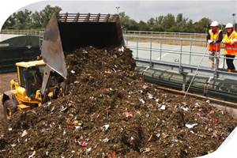
Works Cited:
"Compost • Composting, How to Compost, Fast Composting, Compost Bins." Compost • Composting, How to Compost, Fast Composting, Compost Bins. N.p., n.d. Web. 10 June 2014. <http://www.compost-info-guide.com/>.
"Composters and Bins | Composting 101." Planet Natural RSS. N.p., n.d. Web. 10 June 2014. <http://www.planetnatural.com/composting-101/composters-bins/>.
"Composting Pictures, Images & Photos on Photobucket." Photobucket. N.p., n.d. Web. 10 June 2014. <http://photobucket.com/images/composting?page=1>.
"Environmental Benefits | Composting." EPA. Environmental Protection Agency, n.d. Web. 10 June 2014. <http://www.epa.gov/compost/benefits.htm
"Information About Composting Basics." Composting Basics â Compost Facts And Methods For Composting. N.p., n.d. Web. 10 June 2014. <http://www.gardeningknowhow.com/composting

